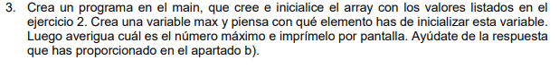
public static void main(String[] args) {
int[] array = {-22, 5, 19, 1, -17, 0, -1, 19, 24, -13};
int max = array[0];
for (int i = 0; i < array.length; i++) {
if (array[i] >= max) {
max = array[i];
}
}
System.out.println("Este es el maximo de la coleccion: " + max);
}

